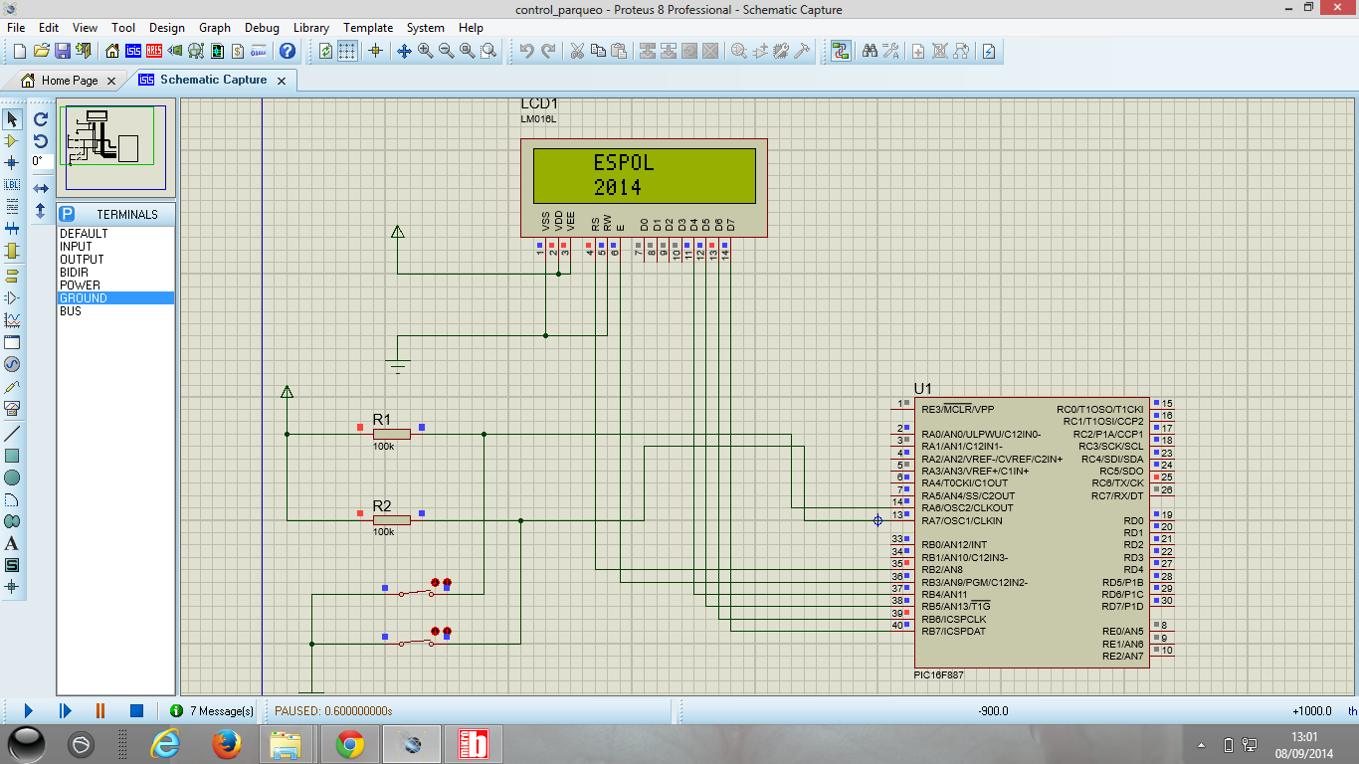

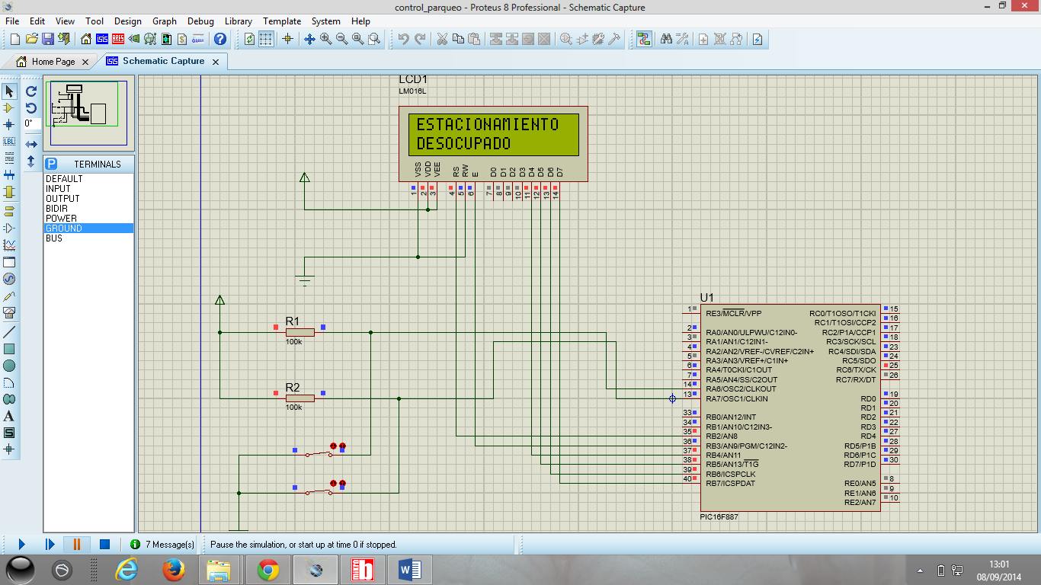

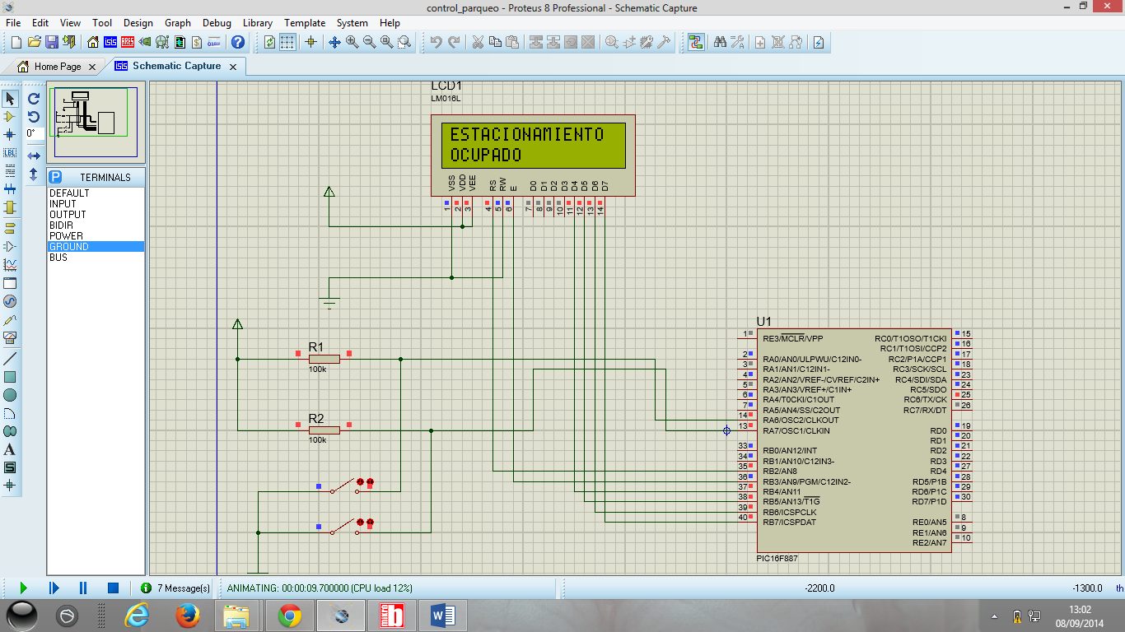

CODIGO

program control_parqueo

' ULTRASONICO 1 'SENSOR FRENTE

SYMBOL DISPARO1 = PORTA.0 'PIN TRIGGER

SYMBOL ECO1 = PORTA.1 'PIN ECHO

' ULTRASONICO 2 'SENSOR ATRAS

SYMBOL DISPARO2 = PORTA.2 'PIN TRIGGER

SYMBOL ECO2 = PORTA.3 'PIN ECHO

DIM LCD_RS AS SBIT AT RB2_BIT

LCD_EN AS SBIT AT RB3_BIT

LCD_D4 AS SBIT AT RB4_BIT

LCD_D5 AS SBIT AT RB5_BIT

LCD_D6 AS SBIT AT RB6_BIT

LCD_D7 AS SBIT AT RB7_BIT

LCD_RS_Direction as sbit at TRISB2_BIT

LCD_EN_Direction as sbit at TRISB3_BIT

LCD_D4_Direction as sbit at TRISB4_BIT

LCD_D5_Direction as sbit at TRISB5_BIT

LCD_D6_Direction as sbit at TRISB6_BIT

LCD_D7_Direction as sbit at TRISB7_BIT

dim distancia1, distancia2,contador as word

DIM S1,S2 AS BIT

DIM TEXTO AS STRING [5]

sub function ultrasonico1( ) as word

dim flanco as byte

dim distan,tiempo as word

flanco = 0

disparo1 = 1

Delay_us(50)

disparo1 = 0

DO

IF( eco1 = 1 )THEN

TMR0 = 0

flanco = 1

END IF

LOOP UNTIL( flanco = 1 )

DO

IF( eco1 = 0 )THEN

tiempo = TMR0

flanco = 0

END IF

if(TMR0>254)THEN

FLANCO=0

END IF

LOOP UNTIL( FLANCO = 0 )

distan = (tiempo*128)/58

Delay_ms (50)

result = distan

end sub

'*******************************************************************************

sub function ultrasonico2( ) as word

dim flanco as byte

dim distan,tiempo as word

flanco = 0

disparo2 = 1

Delay_us(50)

disparo2 = 0

DO

IF( eco2 = 1 )THEN

TMR0 = 0

flanco = 1

END IF

LOOP UNTIL( flanco = 1 )

DO

IF( eco2 = 0 )THEN

tiempo = TMR0

flanco = 0

END IF

if(TMR0>254)THEN

FLANCO=0

END IF

LOOP UNTIL( FLANCO = 0 )

distan = (tiempo*128)/58

Delay_ms (50)

result = distan

end sub

sub procedure servomotor_arriba()

contador=0

while (contador<255)

PORTB.RB0=1

Delay_us(1400)

PORTB.RB0=0

Delay_us(600)

inc(contador)

wend

end sub

sub procedure servomotor_abajo()

contador=0

while (contador<255)

PORTB.RB0=1

Delay_us(1600)

PORTB.RB0=0

Delay_us(400)

inc(contador)

wend

end sub

main:

OSCCON = 0X65

OPTION_REG = %10000110

PORTA =%00000000

TRISA =%11001010

PORTB =%00000000

TRISB =%00000000

PORTC =%00000000

TRISC =%10000000

PORTD =%00000000

TRISD =%00000000

ANSEL =%00000000

ANSELH =%00000000

UART1_Init(9600)

WPUB= 0XFF

Lcd_Init()

Lcd_Cmd(_LCD_CLEAR)

Lcd_Cmd(_LCD_CURSOR_OFF)

Lcd_Out(1,1," ESPOL")

Lcd_Out(2,1," 2014")

Delay_1sec

Delay_1sec

Lcd_Cmd(_LCD_CLEAR)

while (1)

if ((PORTA.RA6=1) AND (PORTA.RA7=1)) then

UART1_Write_Text("O") 'OCUPADO

Lcd_Out(1,1,"ESTACIONAMIENTO")

Lcd_Out(2,1,"OCUPADO")

end if

if ((PORTA.RA6=0) AND (PORTA.RA7=0)) then

UART1_Write_Text("D") 'DESOCUPADO

Lcd_Out(1,1,"ESTACIONAMIENTO")

Lcd_Out(2,1,"DESOCUPADO")

end if

if (PORTA.RA6=1) then

if ( PORTA.RA7=0) then

UART1_Write_Text("E") 'ESPACIO

Lcd_Out(1,1,"ESTACIONAMIENTO")

Lcd_Out(2,1,"DESOCUPADO")

end if

end if

if (PORTA.RA7=1) then

if (PORTA.RA6=0) then

UART1_Write_Text("F") 'ESPACIO

Lcd_Out(1,1,"ESTACIONAMIENTO")

Lcd_Out(2,1,"DESOCUPADO")

end if

end if

Delay_1sec

Lcd_Cmd(_LCD_CLEAR)

wend

end.